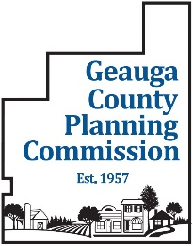
Geauga County Planning Commission
12611 Ravenwood Dr. Suite #380 Chardon, OH 44024
Phone: (440) 279-1740 Email: Planning@co.geauga.oh.us
https://bocc.geauga.oh.gov/departments/planning-commission

GEAUGA COUNTY PLANNING COMMISSION AGENDA
May 12, 2026 REGULAR MEETING
12611 Ravenwood Drive
Conference Room A334, 3rd Floor
7:30 A.M.
Revised 5/7/2026
- Pledge of Allegiance

- Roll Call

- Approval of Minutes:

  - April 14, 2026 Regular Meeting Minutes
  - March 17, 2026 Special Meeting Minutes - Amended

- Approval of Agenda/Addendum:

- Financial Report and Approval of Expenses:

- Other Business:

- Major Subdivisions to be reviewed:

A. Chagrin Falls Park
Replat of Sublots 691 thru 694
Bainbridge Township
Final Plat

B. Klarich Farms Subdivision
Auburn Township
Preliminary Plan

- Township Zoning Amendments to be Reviewed: None

- Director’s Report:

- Correspondence:

- Old Business:

A. Farmland Preservation Plan Update
B. House Bill 733 Draft letter of support from Planning Commission board members

- New Business:

A. Determination of injurious affect (ORC 711.24), Walden Oaks Subdivision No. 3, Sublot 45
B. Housing Start History
C. Review of Geauga County Zoning Regulations – Data Centers

13. Adjournment

